Group A
Initialization 1
Design Variables 1
Inputs 2
Parameters 2
Assumptions 4
Simulink models Paramters 4
2D Model inputs 4
Frame Rail optimization - intialization (comment out after finishing it) 5
Vehicle Mass Calculations 5
Frame Rail calculations 6
Frame Rail optimization - end (comment out after finishing it) 9
Center of Gravity 10
Vehicle Costing Calculations 11
Vehicle Perfromance Model Setting and Parameters 11
Max speed calculations (1 of 3 don't change the sequence) 12
0-100 km/h time calculations (2 of 3 don't change the sequence) 12
Range Calculations calculations (3 of 3 don't change the sequence) 12
Ascend a 12% slope speed (minimum at 30 km/h) 13
Profit calculations 13
Assesing the stability at 100 m radius with up to 0.8 g lateral accleration 13
Spring Constant Calculations 15
Damping Coefficient 16

Initialization
clear all
close all

Design Variables
battery_capacity=40000; %battery capcity in Wh
motorinverter_select='A'; %A, B, or C
configuration='RWD2'; %FWD1, FWD2, RWD1, RWD2, AWD2, or AWD4
drive_ratio=2; %final drive ratio
w=0.080; %(m) frame rail width
h=0.160; %(m) frame rail height
t=0.001; %(m) frame rail thickness
frame_rail_area=(w*h)-((w-(2*t))*(h-(2*t)));
if ((configuration =='FWD1') | (configuration =='RWD1'))
num_motor=1;
num_gearbox=1; %two motors could be connected to the samce GB to double the torque
num_inverter=1;
num_differential=1;
elseif ((configuration =='FWD2') | (configuration =='RWD2'))
num_motor=2;
num_gearbox=1; %two motors could be connected to the samce GB to double the torque
num_inverter=2;
num_differential=1;
elseif (configuration =='AWD2')
num_motor=2;
num_gearbox=2;
num_inverter=2;
num_differential=2;
elseif configuration =='AWD4'
num_motor=4;
num_gearbox=2;
num_inverter=4;
num_differential=2;
end

Inputs
slope=0; %the road slope in %

Parameters
g=9.81; %Gravitational acceleration = 9.81 /2
Cd=0.27; %Drag coefficient Cd = 0.27
r=659.7/1000/2; %for Tire size = 225/4518, the diameter = 659.7 mm
rho=1.26; %Density of air = 1.26 /3
steel_density= 7800; %kg/m^3
frf=1.2; %Front ride requency (Hz)
frr=1.44; %Front ride requency (Hz)
damping_ratio=0.3; %damping ratio
% Dimensions
battery_width=1.25; %max battery width
W103=1820/1000; %vehicle width (m)
W101=1550/1000; %Tread_front
L101=2700/1000; %the wheel base length
if motorinverter_select=='A' %%motor, inverter, and gearbox paratmers
motor_mass=85; %kg
inverter_mass=35; %kg
motorinverter_cost=7500; %dollars
motorinverter_power=175000; %W; continuous
gearbox_mass=45; %high torque gearbox is needed based on the map
gearbox_cost=7500; %high torque gearbox is needed based on the map
motor_cylinder_dia = 0.390;
inverter_box_h = 0.422;
gearbox_h = 0.3;
load MotorA_Data.mat %to load motor A map
elseif motorinverter_select=='B'
motor_mass=41; %kg
inverter_mass=16; %kg
motorinverter_cost=5200; %dollars
motorinverter_power=70000; %W; continuous
gearbox_mass=28; %low torque gearbox is needed based on the map
gearbox_cost=4000; %low torque gearbox is needed based on the map
motor_cylinder_dia = 0.276;
inverter_box_h = 0.393;
gearbox_h = 0.25;
load MotorB_Data.mat %to load motor B map
elseif motorinverter_select=='C'
motor_mass=55; %kg
inverter_mass=12; %kg
motorinverter_cost=5500; %dollars
motorinverter_power=100000; %W; continuous
gearbox_mass=45; %high torque gearbox is needed based on the map
gearbox_cost=7500; %high torque gearbox is needed based on the map
motor_cylinder_dia = 0.28;
inverter_box_h = 0.2;
gearbox_h = 0.3;
load MotorC_Data.mat %to load motor C map
end
%Masses
passenger_mass=101; %kg/passenger; left per passenger to be used in the CG calculations later
cargo_mass=28; %kg (4*7)
info_mass=15; %kg
sunroof_mass=10; %kg
unsprung_mass=60*4; %kg
total_gearbox_mass=gearbox_mass*num_gearbox; %kg (based on the selection)
differential_mass=10; %kg
total_differential_mass= num_differential*differential_mass;
axle_mass=20; %5kg*4halfs
battery_mass=battery_capacity/250; %battery capacity (Wh)/250(Wh/kg) = battery mass (kg)
total_motorinverter_mass=num_motor*(motor_mass+inverter_mass); %kg (based on the selection)
%Volumes
battery_volume=(battery_capacity/600/1000); %m^3
battery_crosssection_area=battery_volume/battery_width;
%Costs
misc_electronics_cost=3000;
wheel_assembly_cost=450*4;
differntial_cost=600;
axles_cost=350;

Assumptions
E=2.15*(10^11); %Young’s Modulus Pa
G=78000; %Shear Modulus N/mm2
Cr=0.009; %Rolling coefficient Cr=0.009
mu=0.9; %Coefficient of friction (dry asphalt) = 0.9
BrkGain = 1e4; %Max Brake effort gain [N]
eff_dl =0.9; %Driveline efficiency [unitless]
useful_battery_capacity=0.95; %the useful capacity of the battery is 90% of the capacity
Jz = 2380; % Moment of inertia of the vehicle [kgm^2]
Caf = 1290; % Tire cornering stiffness front [N/deg]
Car = 3000; % Tire cornering stiffness rear [N/deg]
Cmzf = 30; % Tire aligning stiffness front [Nm/deg]
Cmzr = 20; % Tire aligning stiffness rear [Nm/deg]
MR=0.9; % Motion Ratio

Simulink models Paramters
time_step = 0.05;

2D Model inputs
%%%%%%%%%%%%%%%%%%%%%%%%%%%%%%%%%%%%%%%%%%%%%%%%%%%%%%%%%%%%%%%%%%%%%%%
%%%%%%%%%%%%%%%%%%%%%%%%%%%%%%%%%%%%%%%%%%%%%%%%%%%%%%%%%%%%%%%%%%%%%%%
% LOADS IN FRAME RAIL SECTION NEEDS TO BE UPDATED MANUALLY BASED ON THE
% DESIGN %%%%%%%%%%%%%%%%%%%%%%%%%%%%%%%%%%%%%%%%%%%%%%%%%%%%%%%%%%%%%%
%%%%%%%%%%%%%%%%%%%%%%%%%%%%%%%%%%%%%%%%%%%%%%%%%%%%%%%%%%%%%%%%%%%%%%%
%the below values to be entered from the 2D model and are required for
%calculations, they are just assumed now to run the model
L108=3944/1000; %The total length of the vehicle
H101=1420/1000; %The total vehicle height
battery_thickness=0.05; %battery thickness
L104 = 0.622; %front overhang
H156 = 0.140; % ground clearance
H5_1 = 0.500; % front passenger H-Point
H5_2 = 0.550; % rear passenger H-Point
% X loads locations // needed for the frame rail calculations later
cargofront_X_dis = 0.28; % Cargo (front)
motorf_X_dis = 0.4; % Motor (front)
inverterf_X_dis = 0.4; % Inverter (front)
gearboxf_X_dis = 0.4; % Gearbox (front)
differentialf_X_dis = 0.4; % Differential (front)
frontaxle_X_dis = 0.622; % Axle (front)
batteryfront_X_dis = 0.807; % Battery (front)
infotainment_X_dis = 0.9; % Infortainment
frontpass_X_dis = 1.3+0.622; % Passenger (front)
sunroof_X_dis = 2.0; % Sunroof
body_X_dis = L108/2; % Body
rearpass_X_dis = 2.04+0.622; % Passenger (rear)
motorr_X_dis = 0.622+2.7-0.3; % Motor (rear)
inverterr_X_dis = motorr_X_dis; % Inverter (rear)
gearboxr_X_dis = motorr_X_dis+(0.25/2); % Gearbox (rear)
differentialr_X_dis = gearboxr_X_dis; % Differential (rear)
rearaxle_X_dis = 0.622+2.7; % Axle (rear)
batteryrear_X_dis = 3.4; % Battery (rear)
cargorear_X_dis = 3.944-0.305; % Cargo (rear)
framerail_X_dis_start = 0; % Frame Rail
framerail_X_dis_end = L108; % Frame Rail
% Y loads locations // needed for the frame rail calculations later
cargofront_Y_dis = H156 + 0.436 + 0.225/2 ; % Cargo (front)
motorf_Y_dis = H156 + motor_cylinder_dia/2 ; % Motor (front)
inverterf_Y_dis = H156 + inverter_box_h/2 ; % Inverter (front)
gearboxf_Y_dis = H156 + gearbox_h/2 ; % Gearbox (front)
differentialf_Y_dis = H156 + r ; % Differential (front)
frontaxle_Y_dis = H156 + r ; % Axle (front)
batteryfront_Y_dis = H156 + battery_thickness/2 ; % Battery (front)
infotainment_Y_dis = H5_1; % Infortainment
frontpass_Y_dis = H5_1; % Passenger (front)
sunroof_Y_dis = H101; % Sunroof
body_Y_dis = H101/3; % Body
rearpass_Y_dis = H5_2; % Passenger (rear)
motorr_Y_dis = H156 + motor_cylinder_dia/2 ; % Motor (rear)
inverterr_Y_dis = H156 + inverter_box_h/2 ; % Inverter (rear)
gearboxr_Y_dis = H156 + gearbox_h/2 ; % Gearbox (rear)
differentialr_Y_dis = H156 + r; % Differential (rear)
rearaxle_Y_dis = H156 + r ; % Axle (rear)
batteryrear_Y_dis = H156 + battery_thickness/2 ; % Battery (rear)
cargorear_Y_dis = H156 + 0.436 + 0.225/2; % Cargo (rear)
framerail_Y_dis = H156 + h/2; % Frame Rail

Frame Rail optimization - intialization (comment out after finishing it)
% before activating add ; to stress and the deflection, and deactivvate % plots in SFBM frame_rail_optimization=zeros(0,6); %w,aspect ratio,t,area,stress, deflection aspect_ratio=1; i=0; for w=0.04:0.005:0.15 for aspect_ratio=1:0.5:5 h=w*aspect_ratio; for t=0.001:0.001:0.015 i=i+1; frame_rail_area=(w*h)-((w-(2*t))*(h-(2*t)));

Vehicle Mass Calculations
SI units have been used all through out the simulation unless otherwise stated
frame_rail_mass=3*2*frame_rail_area*L108*7800; %kg (based on the frame rail design and 2D inputs
body_mass=L108*H101*50; %kg
mass=(4*passenger_mass)+cargo_mass+info_mass+sunroof_mass+unsprung_mass+total_gearbox_mass+total_differential_mass+axle_mass+body_mass+frame_rail_mass+battery_mass+total_motorinverter_mass;

Frame Rail calculations
as per the assumptions in the report the below analysis was performed
% calculating the different loads (all of them in N)
load_cargof= -cargo_mass*g/4;
if ((configuration =='RWD1') | (configuration =='RWD2'))
load_motorf=0;
load_inverterf=0;
load_gearboxf=0;
load_differentialf=0;
elseif ((configuration =='FWD2') | (configuration =='AWD4'))
load_motorf= -2*motor_mass*g;
load_inverterf= -2*inverter_mass*g;
load_gearboxf= -1*gearbox_mass*g;
load_differentialf= -1*differential_mass*g;
elseif ((configuration =='FWD1') | (configuration =='AWD2'))
load_motorf= -1*motor_mass*g;
load_inverterf= -1*inverter_mass*g;
load_gearboxf= -1*gearbox_mass*g;
load_differentialf= -1*differential_mass*g;
end
load_axlef= -axle_mass*g/2;
load_batteryf= -battery_mass*g;
load_infotainment= -info_mass*g;
load_passf= -2*passenger_mass*g;
load_sunroof= -sunroof_mass*g;
load_body=-body_mass*g;
load_passr= -2*passenger_mass*g;
if ((configuration =='RWD1') | (configuration =='AWD2'))
load_motorr= -1*motor_mass*g;
load_inverterr= -1*inverter_mass*g;
load_gearboxr= -1*gearbox_mass*g;
load_differentialr= -1*differential_mass*g;
elseif ((configuration =='FWD2') | (configuration =='FWD1'))
load_motorr=0;
load_inverterr=0;
load_gearboxr=0;
load_differentialr=0;
elseif ((configuration =='RWD2') | (configuration =='AWD4'))
load_motorr= -2*motor_mass*g;
load_inverterr= -2*inverter_mass*g;
load_gearboxr= -1*gearbox_mass*g;
load_differentialr= -1*differential_mass*g;
end
load_axler= -axle_mass*g/2;
load_batteryr= -battery_mass*g/4;
load_cargor= -cargo_mass*g;
load_framerail= -frame_rail_mass*g/L108;
% The SFBM function
Name1 = 'Frame Rail';
LengthSupport1 = [L108,L104,(L101+L104)]; % Length and Supports
% Concetrated Loads
F1 = {'CF',load_cargof,cargofront_X_dis};
F2 = {'CF',load_motorf,motorf_X_dis};
F3 = {'CF',load_inverterf,inverterf_X_dis};
F4 = {'CF',load_gearboxf,gearboxf_X_dis};
F5 = {'CF',load_differentialf,differentialf_X_dis};
F6 = {'CF',load_axlef,frontaxle_X_dis};
F7 = {'CF',load_batteryf,batteryfront_X_dis};
F8 = {'CF',load_infotainment,infotainment_X_dis};
F9 = {'CF',load_passf,frontpass_X_dis};
F10 = {'CF',load_sunroof,sunroof_X_dis};
F11 = {'CF',load_body,body_X_dis};
F12 = {'CF',load_passr,rearpass_X_dis};
F13 = {'CF',load_motorr,motorr_X_dis};
F14 = {'CF',load_inverterr,inverterr_X_dis};
F15 = {'CF',load_gearboxr,gearboxr_X_dis};
F16 = {'CF',load_differentialr,differentialr_X_dis};
F17 = {'CF',load_axler,rearaxle_X_dis};
F18 = {'CF',load_batteryr,batteryrear_X_dis};
F19 = {'CF',load_cargor,cargorear_X_dis};
% Distributed Loads
D1 = {'DF',load_framerail,[framerail_X_dis_start,framerail_X_dis_end]};
% Call the function - output in the max bending mometn - N.m
bending_moment=SFBM(Name1,LengthSupport1,F1,F2,F3,F4,F5,F6,F7,F8,F9,F10,F11,F12,F13,F14,F15,F16,F17,F18,F19,D1);
bending_moment_max=max(abs(bending_moment)); %max bending moment
% Calculating the max stress on the beam (the hieghest moment at the most
% far line of the section (the biggest stresses)
second_moment_area=((w*(h^3))/12)-(((w-2*t)*((h-2*t)^3))/12);
stress=(bending_moment_max*(h/2))/(second_moment_area*1000000) %MPa
% Calculating the deflection
% rough assumption of having the vehicle weight affecting at the center
% distance betweeen the two wheels (the most sever condition)
% two supporters and one concentrated load at the middle equals (m.g)
deflection_max=(mass-unsprung_mass)*g*(L101^3)/(48*E*second_moment_area)
stress =
207.7919
deflection_max =
0.0146
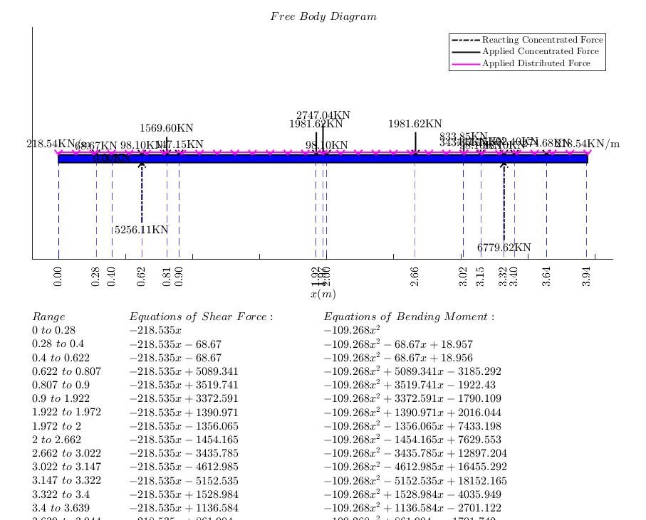
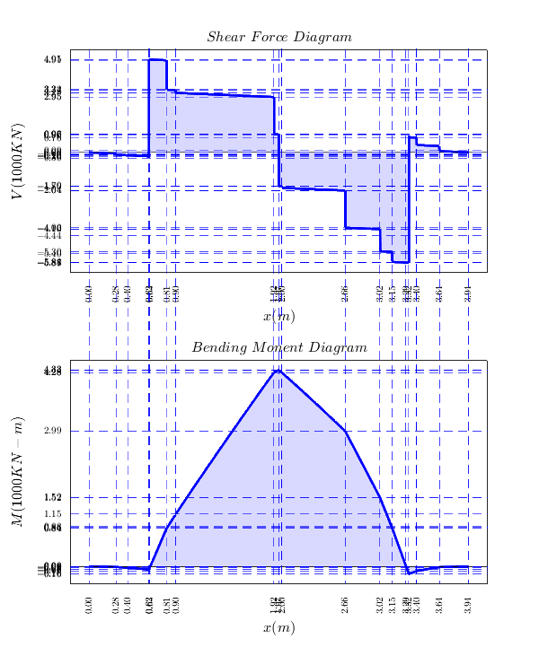

Frame Rail optimization - end (comment out after finishing it)
%w,aspect ratio,t,area,stress, deflection frame_rail_optimization(i,1)=w; frame_rail_optimization(i,2)=aspect_ratio; frame_rail_optimization(i,3)=t; frame_rail_optimization(i,4)=frame_rail_area; frame_rail_optimization(i,5)=stress; frame_rail_optimization(i,6)=deflection_max; end end end

Center of Gravity
mass_x_dis = -1*(load_cargof*cargofront_X_dis ...
+ load_motorf*motorf_X_dis ...
+ load_inverterf*inverterf_X_dis ...
+ load_gearboxf*gearboxf_X_dis ...
+ load_differentialf*differentialf_X_dis ...
+ load_axlef*frontaxle_X_dis ...
+ load_batteryf*batteryfront_X_dis ...
+ load_infotainment*infotainment_X_dis ...
+ load_passf*frontpass_X_dis ...
+ load_sunroof*sunroof_X_dis ...
+ load_body*body_X_dis ...
+ load_passr*rearpass_X_dis ...
+ load_motorr*motorr_X_dis ...
+ load_inverterr*inverterr_X_dis ...
+ load_gearboxr*gearboxr_X_dis ...
+ load_differentialr*differentialr_X_dis ...
+ load_axler*rearaxle_X_dis ...
+ load_batteryr*batteryrear_X_dis ...
+ load_cargor*cargorear_X_dis ...
+(load_framerail*L108)*(L108/2))/g;
mass_CG=mass-unsprung_mass;
CG_a = (mass_x_dis/mass_CG) - L104 ; %L104: front overhang
CG_b = L101 - CG_a;
CG_location=CG_a/L101
mass_Y_dis = -1*(load_cargof*cargofront_Y_dis ...
+ load_motorf*motorf_Y_dis ...
+ load_inverterf*inverterf_Y_dis ...
+ load_gearboxf*gearboxf_Y_dis ...
+ load_differentialf*differentialf_Y_dis ...
+ load_axlef*frontaxle_Y_dis ...
+ load_batteryf*batteryfront_Y_dis ...
+ load_infotainment*infotainment_Y_dis ...
+ load_passf*frontpass_Y_dis ...
+ load_sunroof*sunroof_Y_dis ...
+ load_body*body_Y_dis ...
+ load_passr*rearpass_Y_dis ...
+ load_motorr*motorr_Y_dis ...
+ load_inverterr*inverterr_Y_dis ...
+ load_gearboxr*gearboxr_Y_dis ...
+ load_differentialr*differentialr_Y_dis ...
+ load_axler*rearaxle_Y_dis ...
+ load_batteryr*batteryrear_Y_dis ...
+ load_cargor*cargorear_Y_dis ...
+ (load_framerail*L108)*framerail_Y_dis)/g;
CG_h = mass_Y_dis/mass_CG;
CG_location =
0.5187

Vehicle Costing Calculations
body_cost=1000*W103*L108*H101;
frame_rail_cost=frame_rail_mass*2;
battery_cost=145*battery_capacity/1000;
cost=misc_electronics_cost+wheel_assembly_cost+(gearbox_cost*num_gearbox) ...
+differntial_cost+axles_cost+(num_motor*motorinverter_cost)+body_cost ...
+frame_rail_cost+battery_cost
cost =
4.4419e+04

Vehicle Perfromance Model Setting and Parameters
%road load model
vehicle_frontal_area=H101*W103;
%Forces Distributer Model
front_on=0; %0 means no forces to the front, 1 means forces are going to front
rear_on=0; %0 means no forces to the rear, 1 means forces are going to rear
if ((configuration =='FWD1') | (configuration =='FWD2'))
front_on=1; %0 means no forces to the front, 1 means forces are going to front
rear_on=0; %0 means no forces to the rear, 1 means forces are going to rear
elseif ((configuration =='RWD2') | (configuration =='RWD1'))
front_on=0; %0 means no forces to the front, 1 means forces are going to front
rear_on=1; %0 means no forces to the rear, 1 means forces are going to rear
elseif ((configuration =='AWD4') | (configuration =='AWD2'))
front_on=1; %0 means no forces to the front, 1 means forces are going to front
rear_on=1; %0 means no forces to the rear, 1 means forces are going to rear
end
%Torque multiplication based on the number of engines per axle
torque_multi_factor=0;
if (configuration =='AWD2')
torque_multi_factor=1;
elseif (configuration =='FWD1')
torque_multi_factor=1;
elseif (configuration =='RWD1')
torque_multi_factor=1;
elseif (configuration =='RWD2')
torque_multi_factor=2;
elseif (configuration =='AWD4')
torque_multi_factor=2;
elseif (configuration =='FWD2')
torque_multi_factor=2;
end
%Electrical Motor Model
%Breakpoint values
omega_BP=max(size(EM_Omega_Map));
omega_max_BP=max(size(EM_Omega_Max));
torque_BP=max(size(EM_Torque_Map));
torque__max_BP=max(size(EM_Torque_Max));
%max Torqua and omega
omega_max=max(EM_Omega_Max);
torque__max=max(EM_Torque_Max);
%Drive Cycle Model
load US06_Drive_Cycle.mat
cycle(:,1)=t_cyc;
cycle(:,2)=v_cyc;
Kp = 0.5;
Ki = 0.03;

Max speed calculations (1 of 3 don't change the sequence)
sim_max=sim('Vehicle_Performance_Model_max.slx');
max_speed=max(sim_max.max_velocity_km_per_h) %(m/s)
max_speed =
341.9806

0-100 km/h time calculations (2 of 3 don't change the sequence)
acceleration_time=max(sim_max.acceleration_time_to_hundred_kmh) %(s)
acceleration_time =
6.1500

Range Calculations calculations (3 of 3 don't change the sequence)
sim_range=sim('Vehicle_Performance_Model_range.slx');
range_battery=max(sim_range.range_km) %(km)
range_battery =
162.6164

Ascend a 12% slope speed (minimum at 30 km/h)
slope=0.12; %the road slope in %
sim_slope=sim('Vehicle_Performance_Model_slope.slx');
slope_difference_variation=sim_slope.slope_error.Data(end);
if abs(slope_difference_variation)<0.001
slope_result='[Pass]'
else
slope_result='[Fail]'
end
slope_result =
'[Pass]'

Profit calculations
profit_input=[cost; range_battery; acceleration_time; max_speed];
[profit,demand,price] = profitPredict(profit_input)
profit =
1.9341e+09
demand =
9.5084e+04
price =
6.4760e+04

Assesing the stability at 100 m radius with up to 0.8 g lateral accleration
Kus=(((1-CG_location)*mass)/(2*Caf))-(((CG_location)*mass)/(2*Car))
steeringScenario = 1;
steerAngle = 6; % Ackermann steering angle in [deg]
enablePlotting = false; % turn on the plotting features (off is faster!)
maxYawRate = 20; % [rad/s] -- stop the simulation if yaw rate is >
%Intial values
V = 30; % velocity [m/s] (1 kmph is 40/3.6 m/s)
turning_data = sim('vehicle_dynamics_turning.slx',200);
Turning_data=[turning_data.X.Data turning_data.Y.Data];
[Lc,R,K] = curvature(Turning_data); % external function
radius=mean(R(50:end-1,:)); % excluding the first 50 points before the steady speed
%Determining the speed for 100 m diamter (50 m radius)
while (radius<49.5) || (50.5<radius)
if radius<50
V=V+0.5;
elseif radius>50
V=V-0.5;
end
turning_data = sim('vehicle_dynamics_turning.slx',200);
Turning_data=[turning_data.X.Data turning_data.Y.Data];
[Lc,R,K] = curvature(Turning_data); % external function
radius=mean(R(50:end-1,:)); % excluding the first 50 points before the steady speed
end
% calculating the simulated turning radius
turning_data = sim('vehicle_dynamics_turning.slx',1000);
Turning_data=[turning_data.X.Data turning_data.Y.Data];
[Lc,R,K] = curvature(Turning_data); % external function
radius=mean(R(50:end-1,:)) % excluding the first 50 points before the steady speed
lateral_acceleration_max=max(abs(turning_data.lateral_acceleration.data))
if lateral_acceleration_max>=(g*0.8)
turnning_result='[Pass]'
elseif lateral_acceleration_max<(g*0.8)
turning_result='[Adjust]' %Increase the speed and steering angle
end
figure(1)
plot(turning_data.X.Data,turning_data.Y.Data);
grid on
title('Turning Radius')
xlabel('X')
ylabel('Y')
Kus =
0.1541
radius =
49.9736
lateral_acceleration_max =
9.9976
turnning_result =
'[Pass]'
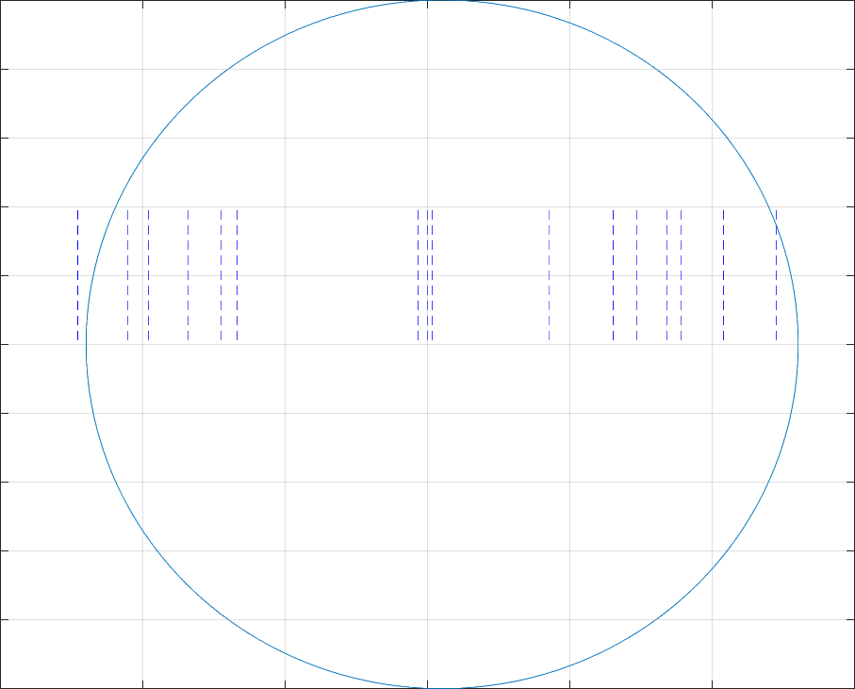

Spring Constant Calculations
front_corners_sprung_mass=(mass-unsprung_mass)*(1-CG_location)/2;
rear_corners_sprung_mass=(mass-unsprung_mass)*(CG_location)/2;
spring_rate_front=4*(pi^2)*(frf^2)*front_corners_sprung_mass*(MR^2) % N
spring_rate_rear=4*(pi^2)*(frr^2)*rear_corners_sprung_mass*(MR^2) % N
spring_rate_front =
1.4404e+04
spring_rate_rear =
2.2355e+04

Damping Coefficient
spring_damping_coeffiecient_front = 4*pi*damping_ratio*frf*front_corners_sprung_mass; %N.s/m
spring_damping_coeffiecient_rear = 4*pi*damping_ratio*frr*rear_corners_sprung_mass; %N.s/m
Published with MATLAB® R2020a

